Evaluator Instructions for using ACETS - Arizona Course Equivalency Tracking System

Go to the AZTRANSFER.COM login page at: [ACETS](https://aztransmac2.asu.edu/cgi-bin/WebObjects/acets) . Click on the ACETS login link.

**Your Username is whatever and your Password is a secret. (You may change either or both of these by clicking on the “My Info” link once you get into your account.)**

The next screen that appears will contain the list of all pending courses that need to be reviewed by you. This list can be sorted by any of the toggle buttons next to the column headings.

The column headings will give quick information about the courses, including the course status. Until a course is evaluated, the status will be Pending, after one month from the date the course was submitted, the status will change to Overdue!.

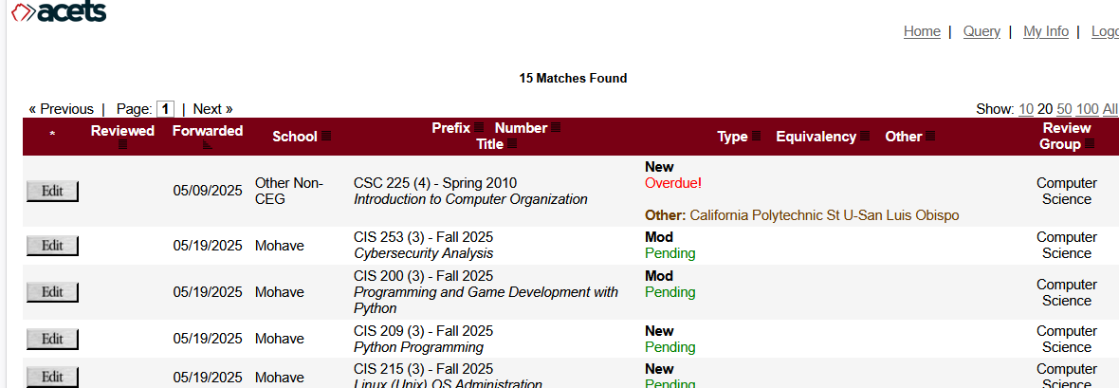

**II.** To evaluate a course, press the “Edit” button that appears to the left of the row.

This will take you to more detailed information about that course.

Under the Course Outline/Description heading, course information may be listed there or it may be a live link to a community college website that will include the course outline and description.

**III.** After reviewing the course information, scroll to the bottom of the page where you will make your evaluation (see picture on next page).   
  
**If the course is to be given a direct equivalency**, enter the course prefix and number, (title is optional) into the first blank field. For some courses, there will be a ‘suggested’ equivalency. If the course is not equivalent to the suggested course, please give a brief reason why that we can pass along to the requestor.  
  
**If the course should be given departmental elective credit**, enter the departmental prefix into the second empty field.   
  
**If the course is University elective credit or not transferable**, check the appropriate box. **If the course is an AZ community college course and being given NT, please briefly explain the reason why. The community colleges require this information in case they need to revise the class in order to make it transferable.**  
  
**Please give each course only *one* equivalency**. Once the evaluation is complete, click the Submit Evaluation button.

**IV.** To return to the list of courses, click the “Return to List” link in the upper right corner of the page. This menu bar appears on every web page.

**V.** Before exiting ACETS, be sure to click the “Logout” link located at the upper right corner of the page.

The “My Info” link can be used to change your current information, including name, title, phone number, username, or password.

There is extensive help information under the “help” button. Feel free to use it. Also, **please do not use the “back” button on your browser**. Instead, use the buttons on the menu bar at the top right hand corner of the pages. Using the “back” button may cause information to be lost.

**If you ever forget your username/password, or need any other kind of help in using ACETS, please contact Mary Ellen Clark at** [**mecf@arizona.edu**](mailto:mecf@arizona.edu)**.** Also, if there are other members of your department that you would like included in the course evaluation process, please contact Mary Ellen.

**You will receive an email when there are courses waiting for your review. Thank you for your help!**