The Transfer Credit and Articulation (TCA) Office uses the Arizona Course Equivalency Tracking System (ACETS) to process courses submitted by AZ community colleges for transfer credit evaluation. This BPG will focus on processing forms in the ACETS system.

Step | Action
1. | Visit https://aztransmac2.asu.edu/cgi-bin/WebObjects/acets to access the ACETS system.  Login with your username and password.  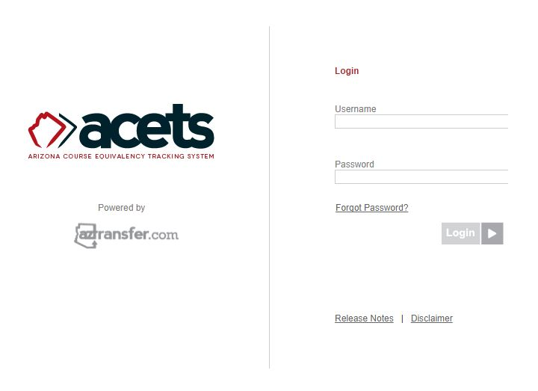
4. | Navigation: Query > New/Mod/SUN/EXM - No Routing Group  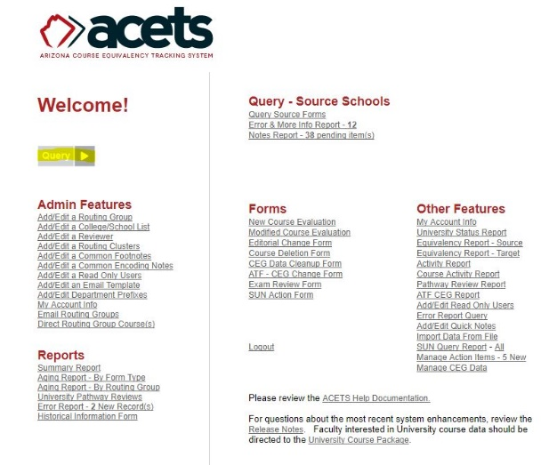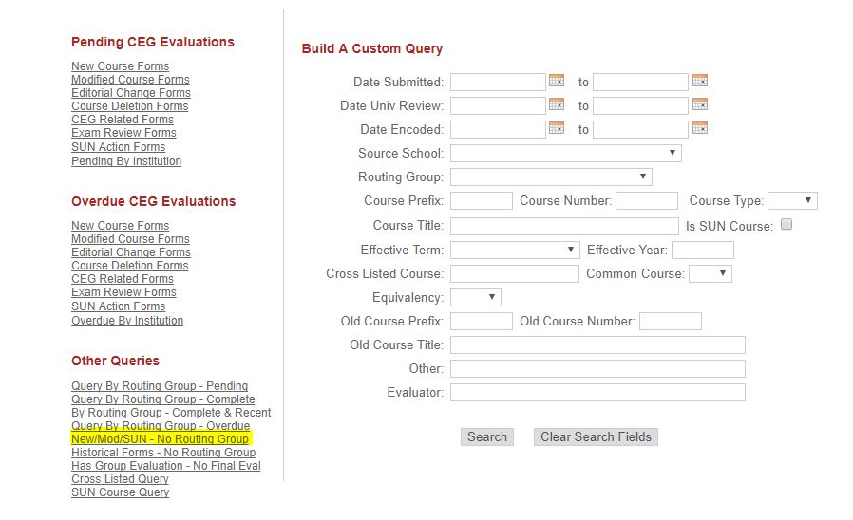  New courses sent for evaluation by the AZ community college will appear on this list. Click “Edit” to begin.  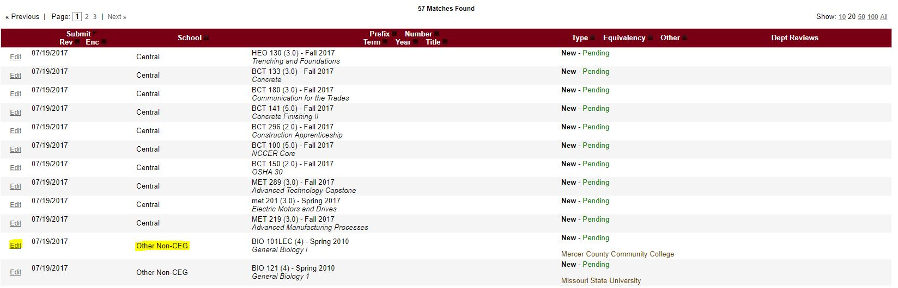  Click on “Associate Routing Group By Link” and select the department that the form should be sent to. In general, courses should be routed to the department that offers the course in the ‘Suggested equivalency’ or that the department that has given the current equivalency (consult the Course Equivalency Guide for the current equivalency, if needed). If there is another department that would also be appropriate, you can always route to more than one department.  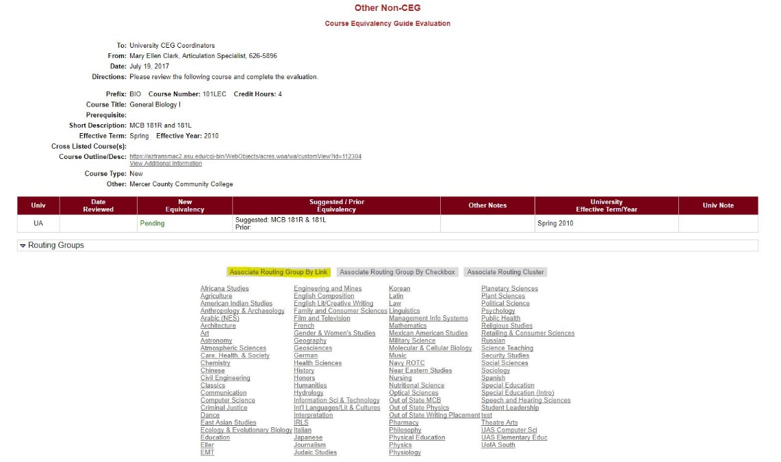
5. | Navigation: Query > Has Group Evaluation - No Final Eval  Forms that have been evaluated by departments will appear in the “Has Group Evaluation - No Final Eval” query.  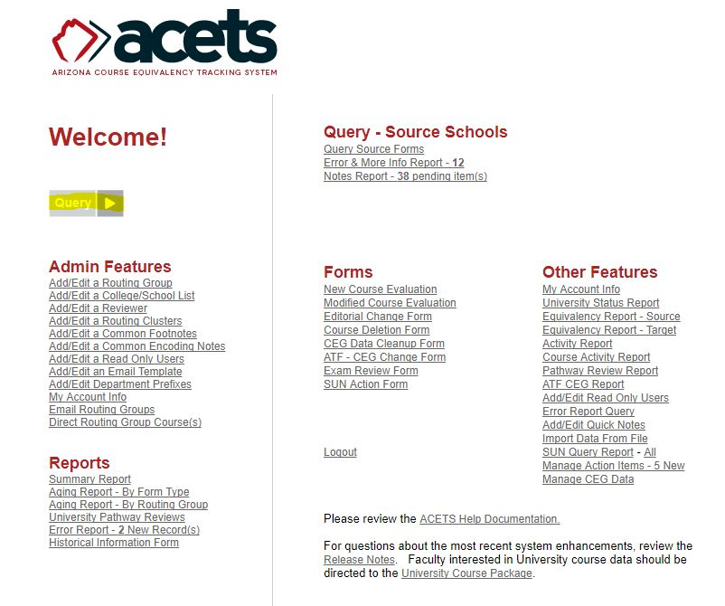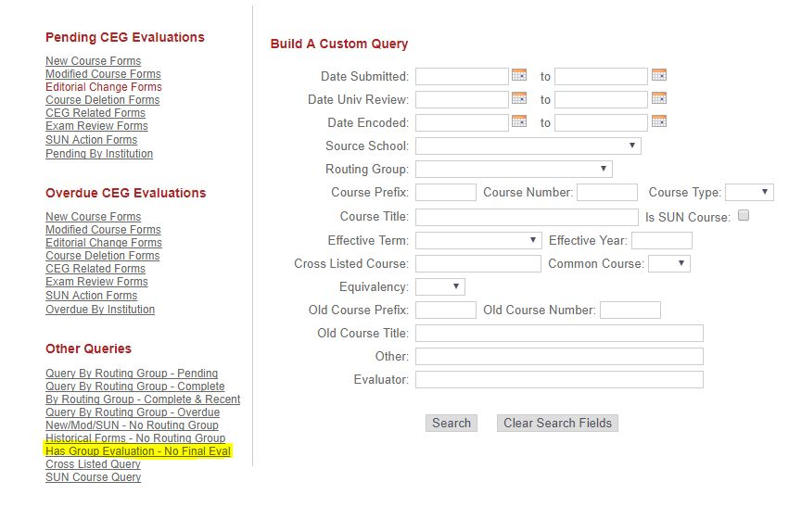  Search for your form from the list and click “Edit.”  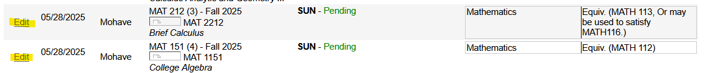  The highlighted information (below) includes the department that the form was sent to, the date it was sent, the date it was reviewed, the equivalency, and the person who evaluated the course. At this point, you can build the rule for the course.  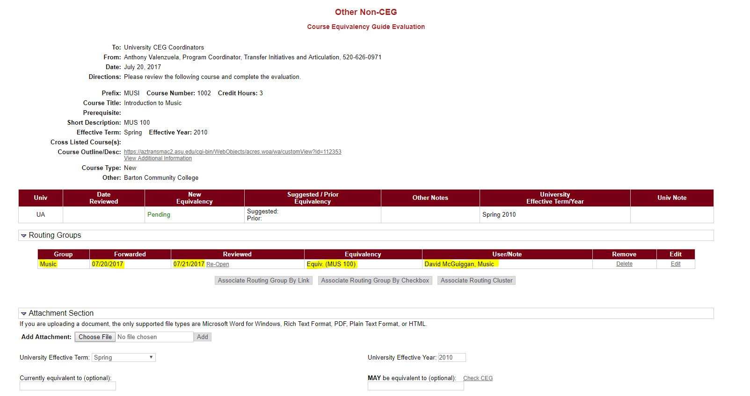  Form continued on next page…  Once you build the rule, complete the form by entering the Source ID in the “Encoding Notes” box, enter the final evaluation in one of the highlighted fields and click “Save.” Next, click “Return to List” to complete other forms or click “Home.”  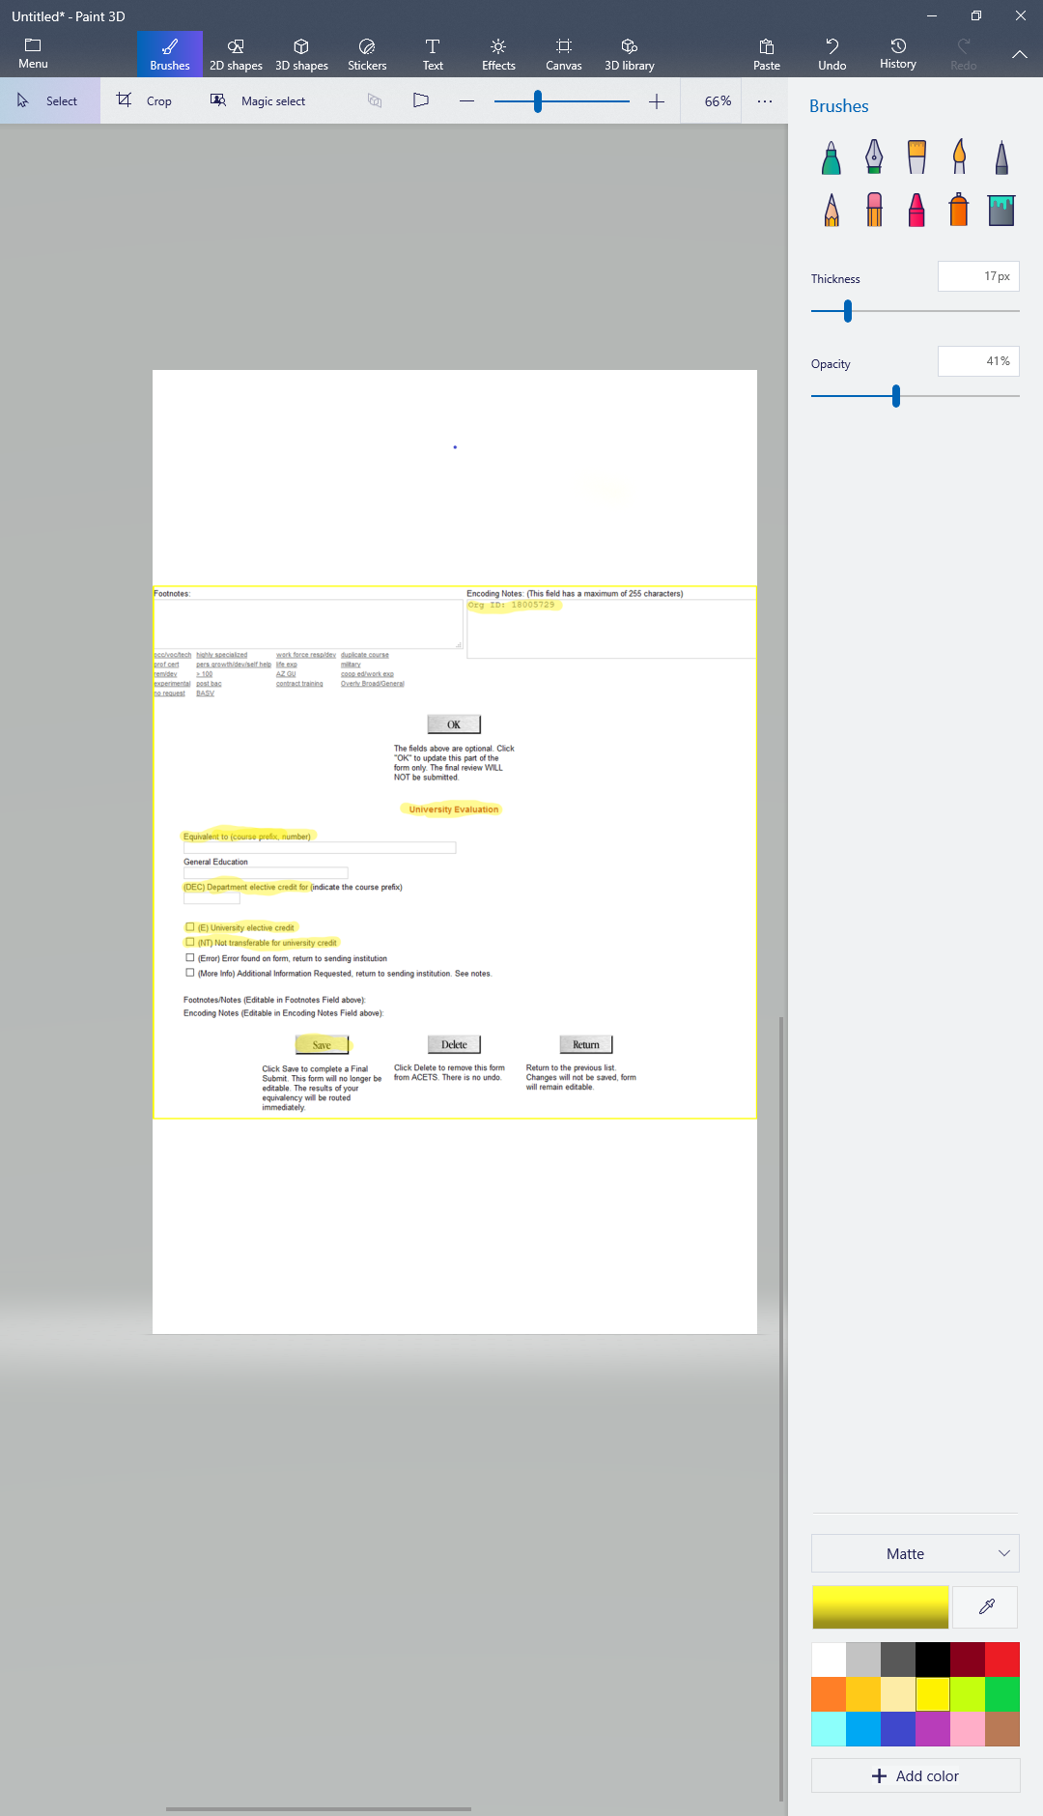

Note:
If the course comes back as Non-transferable (NT) for a new course or for a modified course that was not previously NT, the reviewer should give a reason that can be passed along to the community college. Put the reason into the Footnotes box so that the community college knows why.
If it is an occupational/technical/vocational course and the UA offers nothing similar, that would be a reason for the NT equivalency.
SUN numbered course equivalencies shouldn’t change without warning, although sometimes they do. When this happens, make sure that the evaluator gives a reason. Put the reason into the Footnote box so that the community college can see it. You can include the reviewer’s contact information in case the CC has questions and would like to talk to someone about the change in equivalency. We can act as go-between if necessary, but sometimes it’s easier if the faculty can talk to each other directly.
Changes take about 2 weeks to show in the CEG.

